|  |  |  |
| --- | --- | --- |
| Name: Kaustubh Wade | ER No.: 160410116050 | Class: TYIT-1 Batch-C |

# WINDOWS APPLICATION

# Practical:1

## **Aim:** Use of all basic controls.

1. Button Control:

The Button control is one of the most basic Windows Forms Control. This control lets you generate a Click event by handling the Click event of a Button control.

1. Label Control:

The Label control is one of the commonly used Windows Forms Control. It is generally used to display the text that is not supposed to be changed by the user at runtime, such as caption text for a text box.

1. Textbox Control:

The Textbox Control is an input control that enables you to enter the text on a form at runtime. By default, a Textbox control accepts only a single line of text. However, you can make a Textbox control to accept multiple lines of text, add scroll bars to the control, and disable text editing in the control, by setting various properties of the Textbox control.

1. RichTextBox Control:

It is used for displaying, entering, and manipulating rich text with formatting. This control is similar to the Textbox control, but it lets you make the text of a RichTextBox control bold, italic, and underlined, change the color of the text, select font design and font sizes.

1. RadioButton Control:

It is also known as an option button, is used to select an option from a set of options.

1. CheckBox Control:

It creates a checkbox that can be selected by clicking it. This control accepts either true or false.

1. ListBox Control:

It displays a list of items from which a user can select one or more items.

1. ComboBox Control:

It is used to display data in a drop-down list. It allows the user either to select an item from a list or to enter data in a list through the keyboard.

1. ListView Control:

It is used to display a list of items, such as list of colors.

1. PictureBox Control:

It is used to display graphics from a bitmap icon, JPEG, GIF, or other type of image file.

1. Panel Control:

Panel control is used to group other controls. It is usually used to divide a form into different regions.

|  |  |  |
| --- | --- | --- |
| Name: Kaustubh Wade | ER No.: 160410116050 | Class: TYIT-1 Batch-C |

# Practical:2

## **Aim:** Write a program to make Registration form with following fields:

## Name:

## Address:

## Country:

## Mobile Number:

## Gender:

## DOB:

## Language:

### Code:

using System;

using System.Collections.Generic;

using System.ComponentModel;

using System.Data;

using System.Drawing;

using System.Linq;

using System.Text;

using System.Threading.Tasks;

using System.Windows.Forms;

namespace RegistrationForm

{ public partial class Form : Form

{ public Form()

{ InitializeComponent(); }

private void Form_Load(object sender, EventArgs e)

{ lbl_name.Text = "Name";

lbl_address.Text = "Address";

lbl_country.Text = "Country";

lbl_mobile.Text = "Mobile Number";

lbl_gender.Text = "Gender";

lbl_dob.Text = "DOB";

lbl_language.Text = "Language";

radioButton.Text = "Male";

radioButton2.Text = "Female";

button.Text = "Submit";

}

private void button_Click(object sender, EventArgs e)

{ comboBox_country.Items.Add("India");

comboBox_country.Items.Add("America");

comboBox_country.Items.Add("London");

comboBox_country.Items.Add("Canada");

comboBox_country.Items.Add("Europe");

comboBox_language.Items.Add("English");

comboBox_language.Items.Add("Gujarati");

comboBox_language.Items.Add("Hindi");

comboBox_language.Items.Add("French");

}

}

}

### Output:

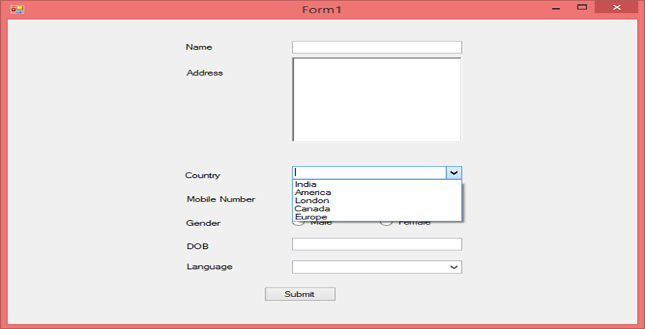

|  |  |  |
| --- | --- | --- |
| Name: Kaustubh Wade | ER No.: 160410116050 | Class: TYIT-1 Batch-C |

# Practical:3

## **Aim:** Write a program to make NOTEPAD.

### Code:

using System;

using System.Windows.Forms;

namespace CompactNotepad

{ public partial class frmNotepad : Form

{ private Boolean FileSavedFlag, ExitFlag;

public frmNotepad()

{ InitializeComponent(); }

private void txtNotepad_TextChanged(object sender, EventArgs e)

{ }

private void mnuWordWrap_Click(object sender, EventArgs e)

{ if(mnuWordWrap.Checked == false)

{ mnuWordWrap.Checked = true;

txtNotepad.WordWrap = true;

}

else

{ mnuWordWrap.Checked = false;

txtNotepad.WordWrap = false;

}

}

private void mnuLeft_Click(object sender, EventArgs e)

{ txtNotepad.TextAlign = HorizontalAlignment.Left;

mnuLeft.Checked = true;

mnuCenter.Checked = false;

mnuRight.Checked = false;

}

private void mnuCenter_Click(object sender, EventArgs e)

{ txtNotepad.TextAlign = HorizontalAlignment.Center;

mnuLeft.Checked = false;

mnuCenter.Checked = true;

mnuRight.Checked = false;

}

private void mnuRight_Click(object sender, EventArgs e)

{ txtNotepad.TextAlign = HorizontalAlignment.Right;

mnuLeft.Checked = false;

mnuCenter.Checked = false;

mnuRight.Checked = true;

}

private void mnuFont_Click(object sender, EventArgs e)

{ fontDialog1.ShowDialog(); //dialog box will be appeareed

txtNotepad.Font = fontDialog1.Font; //applying font properties

}

private void mnuFontColor_Click(object sender, EventArgs e)

{ colorDialog1.ShowDialog();

txtNotepad.ForeColor = colorDialog1.Color;

}

private void mnuBackColor_Click(object sender, EventArgs e)

{ colorDialog1.ShowDialog();

txtNotepad.BackColor = colorDialog1.Color;

}

private void mnuUndo_Click(object sender, EventArgs e)

{ txtNotepad.Undo(); }

private void mnuCut_Click(object sender, EventArgs e)

{ if(txtNotepad.SelectionLength > 0)

{ Clipboard.Clear();

Clipboard.SetText(txtNotepad.SelectedText);

txtNotepad.SelectedText = "";

}

}

private void mnuCopy_Click(object sender, EventArgs e)

{ if (txtNotepad.SelectionLength > 0)

{ Clipboard.Clear();

Clipboard.SetText(txtNotepad.SelectedText);

}

}

private void mnuPaste_Click(object sender, EventArgs e)

{ if(Clipboard.ContainsText())

{ txtNotepad.Paste(); }

}

private void mnuDelete_Click(object sender, EventArgs e)

{ if(txtNotepad.SelectionLength > 0)

{ txtNotepad.SelectedText = ""; }

}

private void mnuClear_Click(object sender, EventArgs e)

{ txtNotepad.Clear(); }

private void mnuSelectAll_Click(object sender, EventArgs e)

{ txtNotepad.SelectAll(); }

private void mnuTimeDate_Click(object sender, EventArgs e)

{ txtNotepad.Text = DateTime.Now.ToString(); }

private void mnuAbout_Click(object sender, EventArgs e)

{ MessageBox.Show("Created by Devangini Kathad"); }

private void frmNotepad_Load(object sender, EventArgs e)

{ mnuWordWrap.Checked = true;

txtNotepad.WordWrap = true;

mnuLeft.Checked = true;

txtNotepad.TextAlign = HorizontalAlignment.Left;

FileSavedFlag = false;

ExitFlag = false;

}

}

}

### Output:

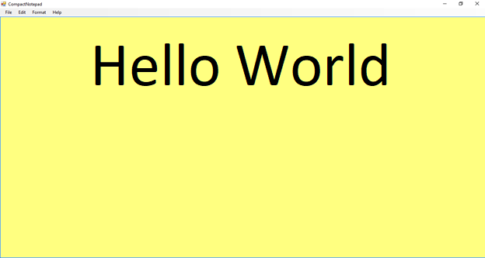

|  |  |  |
| --- | --- | --- |
| Name: Kaustubh Wade | ER No.: 160410116050 | Class: TYIT-1 Batch-C |

# Practical-4

## Aim: Write a program to make web browser.

### Code:

using System;

using System.Collections.Generic;

using System.ComponentModel;

using System.Data;

using System.Drawing;

using System.Linq;

using System.Text;

using System.Threading.Tasks;

using System.Windows.Forms;

namespace Webbrowser

{ public partial class Form1 : Form

{ public Form1()

{ InitializeComponent(); }

private void txtUrl_KeyPress(object sender, KeyPressEventArgs e)

{ if (e.KeyChar == (char)13)

WebBrowser.Navigate(txtUrl.Text);

}

private void btnback_Click(object sender, EventArgs e)

{ WebBrowser.GoBack(); }

private void btnforward_Click(object sender, EventArgs e)

{ WebBrowser.GoForward(); }

private void btnrefresh_Click(object sender, EventArgs e)

{ WebBrowser.Refresh(); }

private void btnGo_Click_1(object sender, EventArgs e)

{ if(!string.IsNullOrEmpty(txtUrl.Text))

WebBrowser.Navigate(txtUrl.Text);

}

}

}

### Output:

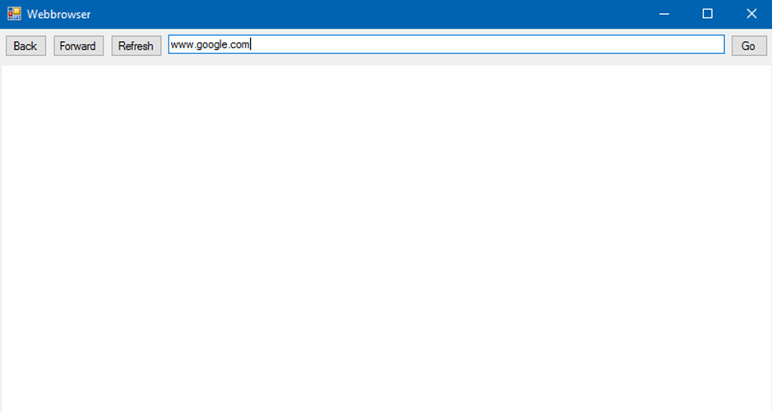

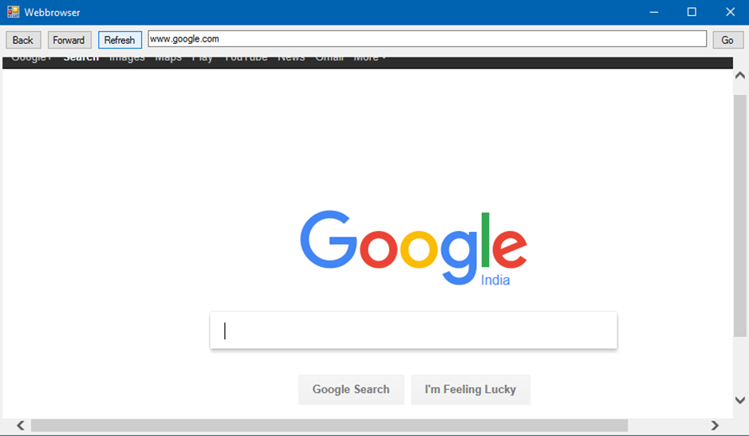

|  |  |  |
| --- | --- | --- |
| Name: Kaustubh Wade | ER No.: 160410116050 | Class: TYIT-1 Batch-C |

# Practical:5

## Aim: Write a program to make ADO.NET application which add, update and delete the record in registration form.

### Code:

using System;

using System.Collections.Generic;

using System.ComponentModel;

using System.Data;

using System.Drawing;

using System.Linq;

using System.Text;

using System.Threading.Tasks;

using System.Windows.Forms;

using System.Data.SqlClient;

namespace ado2

{ publicpartialclassForm1 : Form

{ SqlConnection con=newSqlConnection(@"Data Source=(LocalDB)\v11.0;AttachDbFilename=E:\dotnet\ado2\ado2\Database1.mdf;Integrated Security=True");

SqlCommand cmd;

SqlDataAdapter adapt;

int ID=0;

public Form1()

{ InitializeComponent();

DisplayData();

}

privatevoid Form1_Load(object sender, EventArgs e)

{ }

privatevoid DisplayData()

{ con.Open();

DataTable dt = newDataTable();

adapt = newSqlDataAdapter("select * from self",con);

adapt.Fill(dt);

dataGridView1.DataSource = dt;

con.Close();

}

privatevoid ClearData()

{ txt_name.Text = "";

comboBox1.SelectionStart=0;

ID = 0;

radioButton1.Checked = false;

radioButton2.Checked = false;

}

privatevoid insert_Click(object sender, EventArgs e)

{ string gen = "";

if (txt_name.Text != ""& comboBox1.SelectedItem.ToString() != "Select"& (radioButton1.Checked == true || radioButton2.Checked == true))

{ cmd = newSqlCommand("insert into self(name,branch,gender)values(@name,@branch,@gender)", con);

con.Open();

if (radioButton1.Checked == true)

gen = "Male";

else

gen = "Female";

cmd.Parameters.AddWithValue("@name", txt_name.Text);

cmd.Parameters.AddWithValue("@branch", comboBox1.SelectedItem.ToString());

cmd.Parameters.AddWithValue("@gender", gen);

cmd.ExecuteNonQuery();

MessageBox.Show("Data inserted successfully");

con.Close();

DisplayData();

ClearData();

}

else

{ MessageBox.Show("Please provide details"); }

}

privatevoid comboBox1_SelectedIndexChanged(object sender, EventArgs e)

{ // comboBox1.SelectedItem="Select"; }

privatevoid update_Click(object sender, EventArgs e)

{ string gen = "";

if (txt_name.Text != ""& comboBox1.SelectedItem.ToString() != "Select"& (radioButton1.Checked == true || radioButton2.Checked == true))

{ cmd = newSqlCommand("update self set name=@name,branch=@branch,gender=@gender where ID=@id", con);

con.Open();

if (radioButton1.Checked == true)

gen = "Male";

else

gen = "Female";

cmd.Parameters.AddWithValue("@id", ID);

cmd.Parameters.AddWithValue("@name", txt_name.Text);

cmd.Parameters.AddWithValue("@branch", comboBox1.SelectedItem.ToString());

cmd.Parameters.AddWithValue("@gender", gen);

cmd.ExecuteNonQuery();

MessageBox.Show("Data updated successfully");

con.Close();

DisplayData();

ClearData();

}

}

privatevoid dataGridView1_RowHeaderMouseClick(object sender, DataGridViewCellMouseEventArgs e)

{ ID=Convert.ToInt32(dataGridView1.Rows[e.RowIndex].Cells[0].Value.ToString());

txt_name.Text = dataGridView1.Rows[e.RowIndex].Cells[1].Value.ToString();

comboBox1.SelectedItem = dataGridView1.Rows[e.RowIndex].Cells[2].Value.ToString();

string gen = dataGridView1.Rows[e.RowIndex].Cells[3].Value.ToString();

if(gen=="Male")

radioButton1.Checked=true;

else

radioButton2.Checked=true;

}

privatevoid delete_Click(object sender, EventArgs e)

{ if (txt_name.Text != ""& comboBox1.SelectedItem.ToString() != "Select"& (radioButton1.Checked == true || radioButton2.Checked == true))

{ cmd = newSqlCommand("delete from self where name=@name", con);

con.Open();

cmd.Parameters.AddWithValue("@name", txt_name.Text);

cmd.ExecuteNonQuery();

con.Close();

DisplayData();

ClearData();

}

}

}

### Output:

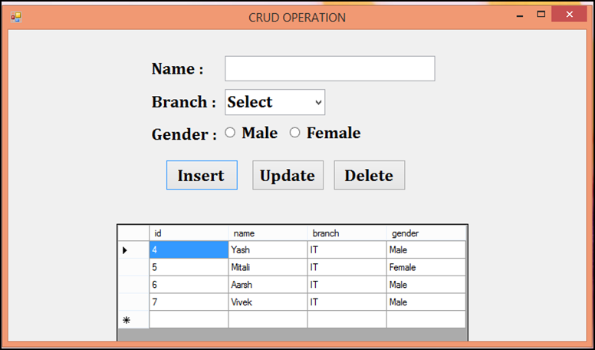

|  |  |  |
| --- | --- | --- |
| Name: Kaustubh Wade | ER No.: 160410116050 | Class: TYIT-1 Batch-C |

# WEB APPLICATION (ASP.NET,C#)

# Practical:1

## Aim: Write a code for Login control.

### Code:

<%@PageTitle=""Language="C#"MasterPageFile="~/MasterPage.master"AutoEventWireup="true"CodeFile="Login.aspx.cs"Inherits="Login"%>

<asp:ContentID="Content1"ContentPlaceHolderID="ContentPlaceHolder1"Runat="Server">

<script type="text/javascript">

function bkclryl(txtbox)

{ txtbox.style.background = "yellow"; }

function bkclrwt(txtbox)

{ txtbox.style.background = "white"; }

</script>

<table style="width:100%;">

<tr>

<td style="font-family:Arial; text-align:right; font-size:40px; color:gray;">

<table style="width:100%;">

<tr>

<td style="width:45%;"></td>

<td> <tablestyle="width:100%;"class="text">

<tr style="height:40px;">

<td colspan="3"style="font-size:25px; color:white; background-color:gray;"> LOGIN INFORMATION </td>

</tr>

<tr style="height:15px;">

<td colspan="3"></td>

</tr>

<tr>

<td style="text-align:left; height: 29px;"> Username </td>

<td style="text-align:center; height: 29px;"> : </td>

<td style="text-align:left; height: 29px;">

<asp:TextBoxID="txtUName" runat="server" CssClass="txtbx" onfocus="bkclryl(this)" onblur="bkclrwt(this)"> </asp:TextBox>

<asp:RequiredFieldValidatorID="rfvUName" runat="server" ErrorMessage="Please Enter User-Name" ForeColor="Red" SetFocusOnError="true" ControlToValidate="txtUName"> </asp:RequiredFieldValidator>

</td>

</tr>

<tr>

<td style="text-align:left;"> Password </td>

<td style="text-align:center;"> : </td>

<td style="text-align:left;">

<asp:TextBoxID="txtPasswd" runat="server" CssClass="txtbx" onfocus="bkclryl(this)" onblur="bkclrwt(this)"> </asp:TextBox>

<asp:RequiredFieldValidatorID="rfvPasswd"runat="server"ErrorMessage="Please Enter Password"ForeColor="Red"SetFocusOnError="true"ControlToValidate="txtPasswd"></asp:RequiredFieldValidator>

</td>

</tr>

<tr style="height:15px;">

<tdcolspan="3"></td>

</tr>

<tr>

<td></td>

<tdcolspan="2">

<asp:ButtonID="btnLogin" runat="server" Text="Login"CssClass="btn" OnClick="btnLogin_Click"/>

&nbsp

<asp:ButtonID="btnSignUp"runat="server"Text="Sign Up"CssClass="btn"PostBackUrl="~/register.aspx"CausesValidation="false"/>

</td>

</tr>

<tr>

<td colspan="3"style=" background-color:gray; text-align:left;">

<asp:LabelID="lblErrMsg"runat="server"ForeColor="Yellow"></asp:Label>

</td>

</tr>

</table>

</td>

</tr>

</table>

</td>

</tr>

</table>

</asp:Content>

### Output:

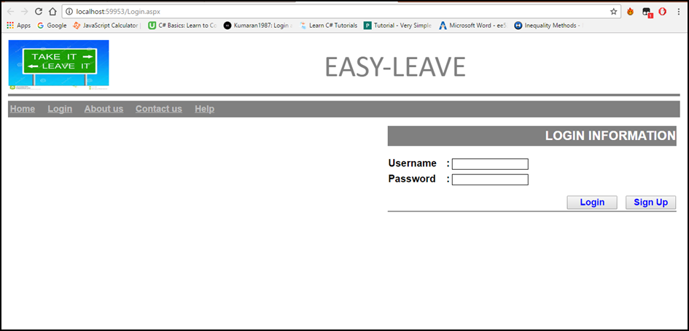

|  |  |  |
| --- | --- | --- |
| Name: Kaustubh Wade | ER No.: 160410116050 | Class: TYIT-1 Batch-C |

# Practical:2

## **Aim:** Make a registration form with all validation.

### Code:

<%@PageTitle=""Language="C#"MasterPageFile="~/MasterPage.master"AutoEventWireup="true"CodeFile="register.aspx.cs"Inherits="register"%>

<asp:ContentID="Content2"ContentPlaceHolderID="ContentPlaceHolder1"Runat="Server">

<table class="text">

<tr>

<td class="auto-style2">Username:</td>

<td>

<asp:TextBoxID="uname" runat="server" Width="180px" CssClass="txtbx"> </asp:TextBox>

</td>

<td>

<asp:RequiredFieldValidatorID="RequiredFieldValidator1"runat="server"ControlToValidate="uname"ErrorMessage="Username Required"ForeColor="Red"></asp:RequiredFieldValidator>

</td>

<td>&nbsp;</td>

</tr>

<tr>

<td style="align-items:flex-start">&nbsp;&nbsp;&nbsp;&nbsp;&nbsp;&nbsp;&nbsp; Contact no:</td>

<td>

<asp:TextBoxID="cntct" CssClass="txtbx" runat="server" Width="180px"> </asp:TextBox>

</td>

<td>

<asp:RequiredFieldValidatorID="RequiredFieldValidator2" runat="server" ControlToValidate="cntct" ErrorMessage="Must be 10 digit" ForeColor="Red"> </asp:RequiredFieldValidator>

</td>

<td>&nbsp;</td>

</tr>

<tr>

<td class="auto-style2">Designation:</td>

<td>

<asp:TextBoxID="desig" CssClass="txtbx" runat="server" Width="180px"> </asp:TextBox>

</td>

<td>&nbsp;</td>

<td>&nbsp;</td>

</tr>

<tr>

<td class="auto-style6">Gender:</td>

<td class="auto-style7">

&nbsp;<asp:DropDownListID="gender"runat="server"CssClass="txtbx">

<asp:ListItem>Male</asp:ListItem>

<asp:ListItem>Female</asp:ListItem>

</asp:DropDownList>

</td>

<td class="auto-style7"></td>

<td class="auto-style7"></td>

</tr>

<tr>

<td class="auto-style8">E-mail:</td>

<td class="auto-style9">

<asp:TextBoxID="email"runat="server"CssClass="txtbx"Width="180px"TextMode="Email"></asp:TextBox>

</td>

<td class="auto-style9">

<asp:RequiredFieldValidatorID="RequiredFieldValidator3"runat="server"ControlToValidate="email"ErrorMessage="Email required"ForeColor="Red"></asp:RequiredFieldValidator>

<br/> </td>

<td class="auto-style9">

<asp:RegularExpressionValidatorID="RegularExpressionValidator1"runat="server"ControlToValidate="email"ErrorMessage="Need to enter valid email id"ForeColor="Red"ValidationExpression="\w+([-+.']\w+)*@\w+([-.]\w+)*\.\w+([-.]\w+)*"></asp:RegularExpressionValidator>

</td>

</tr>

<tr>

<td class="auto-style10">Password:</td>

<td class="auto-style11">

<asp:TextBoxID="pass"runat="server"CssClass="txtbx"Width="180px"TextMode="Password"></asp:TextBox>

</td>

<td class="auto-style11">

<asp:RequiredFieldValidatorID="RequiredFieldValidator4"runat="server"ControlToValidate="pass"ErrorMessage="RequiredFieldValidator"ForeColor="Red">Password required</asp:RequiredFieldValidator>

</td>

<td class="auto-style11"></td>

</tr>

<tr>

<td class="auto-style2">Confirm Password:</td>

<td>

<asp:TextBoxID="conpas"runat="server"CssClass="txtbx"Width="180px"TextMode="Password"></asp:TextBox>

</td>

<td>

<asp:RequiredFieldValidatorID="RequiredFieldValidator5"runat="server"ControlToValidate="conpas"ErrorMessage="RequiredFieldValidator"ForeColor="Red">Confirm Password</asp:RequiredFieldValidator>

<br/>

<asp:CompareValidatorID="CompareValidator1"runat="server"ControlToCompare="pass"ControlToValidate="conpas"ErrorMessage="Both pass must match"ForeColor="Red"></asp:CompareValidator>

</td>

<td>&nbsp;</td>

</tr>

<tr>

<td class="auto-style3">&nbsp;</td>

<td>

<asp:ButtonID="submit"runat="server"CssClass="btn"Text="Submit"OnClick="submit_Click1"/>

&nbsp;&nbsp;&nbsp;&nbsp;

<asp:ButtonID="reset"runat="server"CssClass="btn"Text="Reset"/>

</td>

<td>&nbsp;</td>

<td>&nbsp;</td>

</tr>

<tr>

<td class="auto-style3">&nbsp;</td>

<td>&nbsp;</td>

<td>&nbsp;</td>

<td>&nbsp;</td>

</tr>

<tr>

<td class="auto-style3">&nbsp;</td>

<td>&nbsp;</td>

<td>&nbsp;</td>

<td>&nbsp;</td>

</tr>

<tr>

<td class="auto-style3">&nbsp;</td>

<td>&nbsp;</td>

<td>&nbsp;</td>

<td>&nbsp;</td>

</tr>

</table>

</asp:Content>

<asp:ContentID="Content3"runat="server"contentplaceholderid="head">

<styletype="text/css">

.auto-style2

{ text-align: right;

width: 156px;

}

.auto-style3

{ width: 156px; }

.auto-style6

{ text-align: right;

width: 156px;

height: 34px;

}

.auto-style7

{ height: 34px; }

.auto-style8

{ text-align: right;

width: 156px;

height: 48px;

}

.auto-style9

{ height: 48px; }

.auto-style10

{ text-align: right;

width: 156px;

height: 28px;

}

.auto-style11

{ height: 28px; }

</style>

</asp:Content>

### Output:

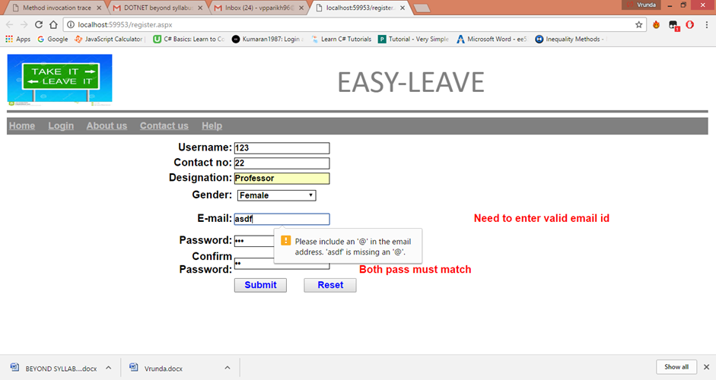

|  |  |  |
| --- | --- | --- |
| Name: Kaustubh Wade | ER No.: 160410116050 | Class: TYIT-1 Batch-C |

# Practical:3

## **Aim:** Design page with theme, skin.

### Default.aspx:

<%@PageLanguage="C#"Theme="Blue"CodeFile="Default.aspx.cs"Inherits="_Default"%>

<!DOCTYPEhtml>

<htmlxmlns="http://www.w3.org/1999/xhtml">

<headrunat="server">

<title></title>

</head>

<body>

<formid="form1"runat="server">

<div>

<asp:ButtonID="Button1"runat="server"Text="Button"/>

&nbsp;&nbsp;&nbsp;&nbsp;&nbsp;&nbsp;&nbsp;&nbsp;&nbsp;&nbsp;&nbsp;

<asp:ButtonID="Button2"runat="server"Text="Button"/>

&nbsp;&nbsp;&nbsp;&nbsp;&nbsp;&nbsp;&nbsp;&nbsp;&nbsp;

<asp:ButtonID="Button3"runat="server"Text="Button"/>

&nbsp;&nbsp;&nbsp;&nbsp;&nbsp;&nbsp;&nbsp;&nbsp;&nbsp;

<asp:ButtonID="Button4"runat="server"Text="Button"/>

<br/> <br/>

<asp:LabelID="Label1"runat="server"Text="Label"></asp:Label>

<br/> <br/>

<asp:TextBoxID="TextBox1"runat="server"></asp:TextBox>

</div>

</form>

</body>

</html>

### Skin:

<%--

Default skin template. The following skins are provided as examples only.

1. Named control skin. The SkinId should be uniquely defined because

duplicate SkinId's per control type are not allowed in the same theme.

<asp:GridView runat="server" SkinId="gridviewSkin" BackColor="White" >

<AlternatingRowStyle BackColor="Blue" />

</asp:GridView>

1. Default skin. The SkinId is not defined. Only one default

control skin per control type is allowed in the same theme.

<asp:Image runat="server" ImageUrl="~/images/image1.jpg" />

--%>

<asp:Buttonrunat="server"BackColor="#003399"ForeColor="White"/>

<asp:Labelrunat="server"BackColor="#003399"ForeColor="White"></asp:Label>

<asp:TextBoxrunat="server"BorderColor="#003399"BorderStyle="Groove"></asp:TextBox>

### Output:

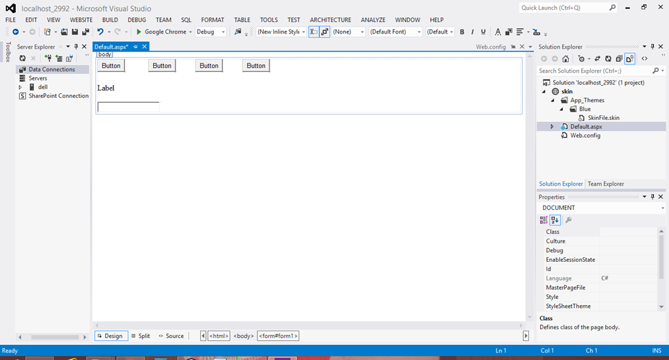

|  |  |  |
| --- | --- | --- |
| Name: Kaustubh Wade | ER No.: 160410116050 | Class: TYIT-1 Batch-C |

# Practical:4

## **Aim:** Write a program to insert, delete, update , delete , select in grid view**.**

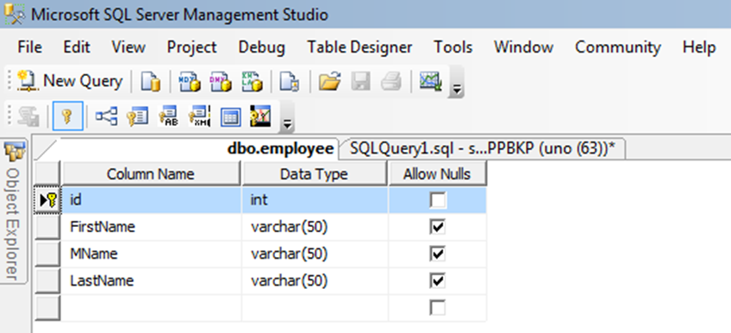Default.aspx

<form id="form1"runat="server">

<div>

First Name  <asp:TextBox ID="TextBox1" runat="server"></asp:TextBox>

Middle Name<asp:TextBox ID="TextBox2" runat="server"></asp:TextBox>

Last Name <asp:TextBox ID="TextBox3" runat="server"></asp:TextBox>

<asp:ButtonID="Button1"runat="server"Text="save"onclick="Button1_Click" />

</div>

<asp:HiddenField ID="HiddenField1" runat="server"/>

<asp:GridViewID="GridView1"runat="server" >

</asp:GridView>-

</form>

### Default2.aspx

protected void empsave(object sender, EventArgs e)  
{ connection();

query =  "studentEntryView"; //Stored Procedure name

SqlCommand com = new SqlCommand(query, con);

com.CommandType = CommandType.StoredProcedure;

com.Parameters.AddWithValue("@Action", HiddenField1.Value).ToString();

com.Parameters.AddWithValue("@FName",TextBox1.Text.ToString());

com.Parameters.AddWithValue("@Mname ", TextBox2.Text.ToString());

com.Parameters.AddWithValue("@LName ",TextBox3.Text.ToString());

com.ExecuteNonQuery();

Label1.Visible = true;

Label1.Text = "Records are Submitted Successfully";  
}

public void viewdata()

{ connection();

query = "studentEntryView";

SqlCommand com = new SqlCommand(query, con);

com.CommandType = CommandType.StoredProcedure;

com.Parameters.AddWithValue("@Action", HiddenField2.Value).ToString();

DataSet ds =new DataSet();

SqlDataAdapter da =  new SqlDataAdapter(com);

da.Fill(ds);

GridView1.DataSource = ds;

GridView1.DataBind();  
}

protected void edit(objectsender, GridViewEditEventArgs e)

{ GridView1.EditIndex= e.NewEditIndex;

gedata();

}

protected void delete(object sender, GridViewDeleteEventArgs e)

{ connection();

int id =  int.Parse(GridView1.DataKeys[e.RowIndex].Value.ToString());

HiddenField1.Value = "Delete";

query = "EmpEntry";

com = new SqlCommand(query, con);

com.CommandType =CommandType .StoredProcedure;

com.Parameters.AddWithValue("@Action", HiddenField1.Value).ToString();

com.Parameters.AddWithValue("id", SqlDbType.Int).Value = id;

com.ExecuteNonQuery();

con.Close();

gedata();

 }

protected void update(object sender, GridViewUpdateEventArgs e)

{ connection();

int id=int.Parse(GridView1.DataKeys[e.RowIndex].Value.ToString());

HiddenField1.Value = "update";

query = "EmpEntry";

com = new SqlCommand(query, con);

com.CommandType = CommandType.StoredProcedure;

com.Parameters.AddWithValue("@Action", HiddenField1.Value).ToString();

com.Parameters.AddWithValue("@FName", ((TextBox)GridView1.Rows[e.RowIndex].Cells[3].Controls[0]).Text.ToString());

.Parameters.AddWithValue("@MName", ((TextBox)GridView1.Rows[e.RowIndex].Cells[4].Controls[0]).Text.ToString());

.Parameters.AddWithValue("@LName", ((TextBox)GridView1.Rows[e.RowIndex].Cells[5].Controls[0]).Text.ToString());

com.Parameters.AddWithValue("@id", SqlDbType.int ).Value = id;

.ExecuteNonQuery();

con.Close();

GridView1.EditIndex = -1;

gedata();

}

### Data Insert

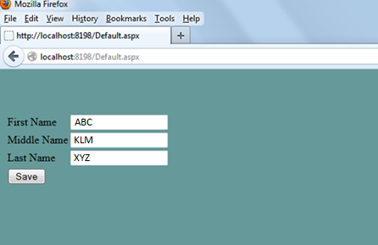

### Data Inserted into Table

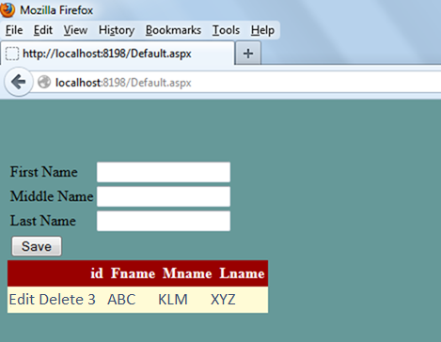

### Edit Record

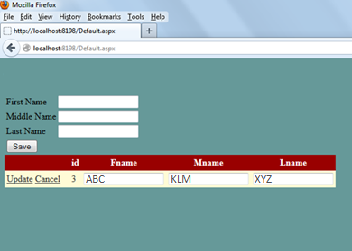

### Update the Record

